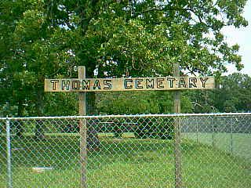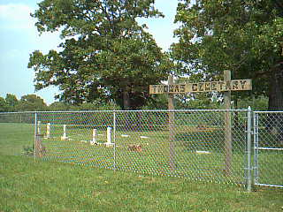

Entrance to the Arbuckle/Thomas Cemetery

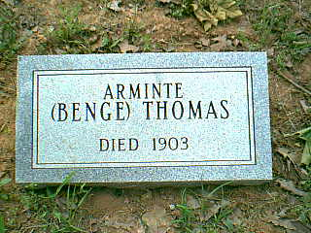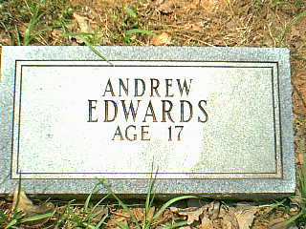

Arminte (Benge) Thomas Andrew Edwards
Died 1903 Age 17

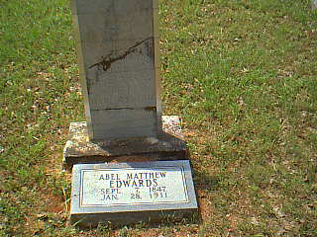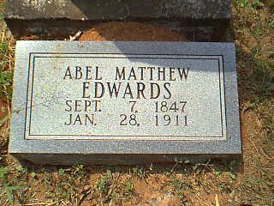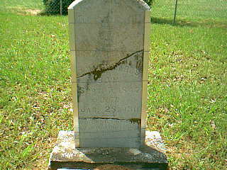

Abel Matthew Edwards
Sept 7, 1847 – Jan 28, 1911

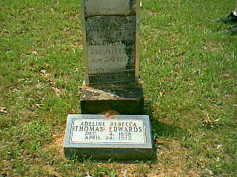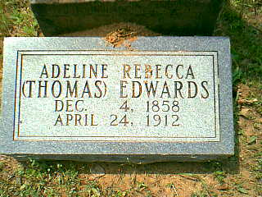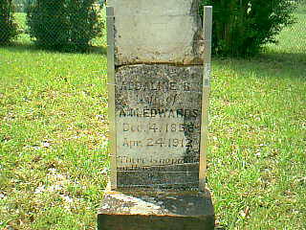

Adeline Rebecca (Thomas) Edwards
Dec 4, 1858 – April 24, 1912

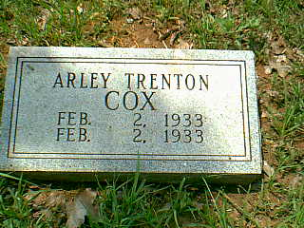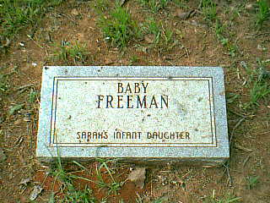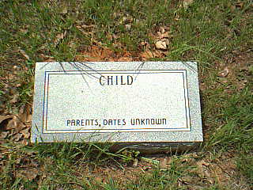

Arley Trenton Cox Baby Freeman Child Unknown
Feb 2, 1933 – Feb 2, 1933 Sarah’s Infant Daughter Parents, Dates Unknown

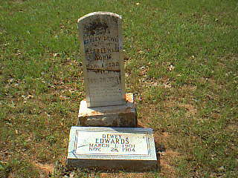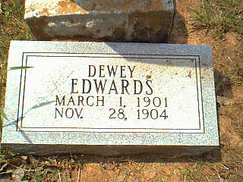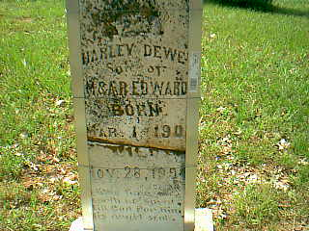

Charley Dewey Edwards
March 1, 1901 – Nov 28, 1904

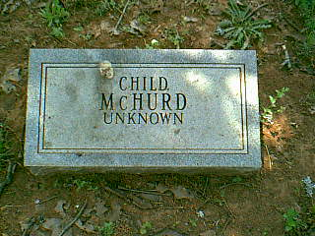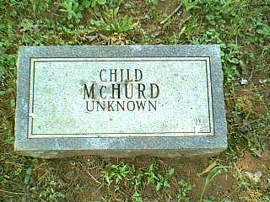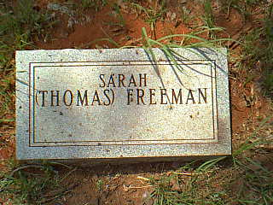

Child McHurd Child McHurd Sarah (Thomas) Freeman
Unknown Unknown no dates – daughter of Jacob & Arminta Thomas

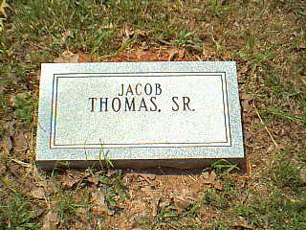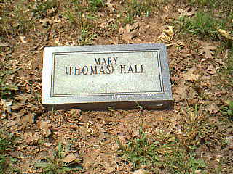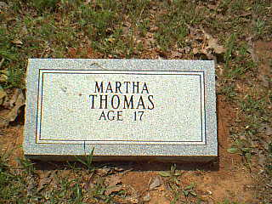

Jacob Thomas Sr. Mary (Thomas) Hall Martha Thomas
No dates Daughter of Jacob Thomas Sr. Age 17- Daughter of Jacob Thomas Sr.
Oldest Grave in Cemetery and Arminta (Benge) Thomas

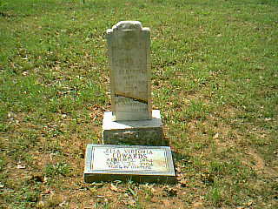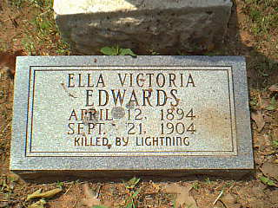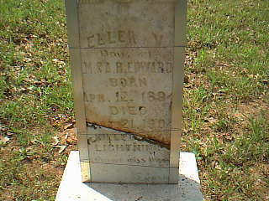

Ella Victoria Edwards
April 12, 1894 – Sept 21, 1904
Killed by Lightning

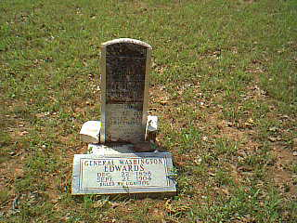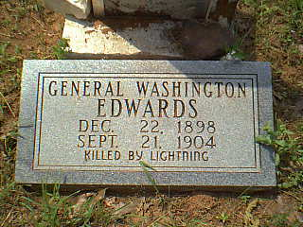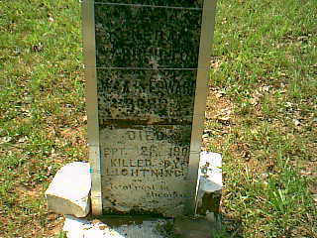

General Washington Edwards
Dec 22, 1898 – Sept 21, 1904
Killed by Lightning

